ECE408 MT2 Cheat Sheet:
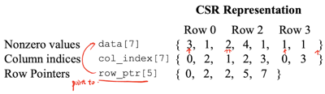
1. Reduction: ˚ must be associative and commutative, have an identity value.
˚ The parallel algorithm shown is work-efficient(as it doesn’t do more work than sequential method) (比较or求和N-1次).
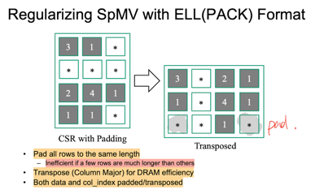
˚__syncthreads() ensures all elements of partial sum generated before next step uses them. To control branch divergence:
for (unsigned int stride = blockDim.x;stride >= 1; stride /= 2)
{__syncthreads(); if (t < stride) partialSum[t] += partialSum[t+stride];}
˚ The problem is memory-bound: • one operation for every 4B value read; • so focus on memory coalescing and avoiding poor computational resource use.
˚ Smaller blocks might seem attractive: • when one warp is active, each SM has one warp per block. Better, • stop reducing at 32 elements(or 64, 128),and hand off to the next kernel. OR Work Until the Data is Exhausted! Compute only until some threads not needed. Then load more data! 减少launching kernel次数，expensive.
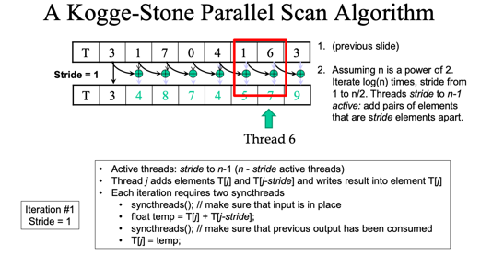
2. Scan: ˚多一次赋值，两个syncthreads(); ˚必须double buffer，因为不同threads的进度完全无法确定，1 syncthreads()
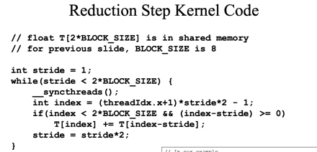
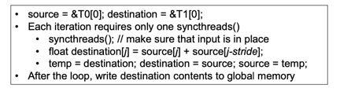
˚ Not work-efficient, need NlogN operations (N for sequential)
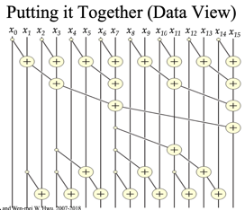
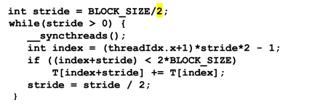
˚ Brent-Kung Scan: 2(n-1)-log(n) -> O(n) work. No more than twice of sequential algorithm.
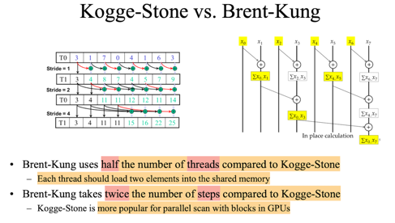
Exclusive (exclude n), same but shift the whole sum array. Or add a zero into the array and calculate.
3. Atomic Operations & Histogramming
When two threads write to the same memory location, we need atomic operations. Atomicity is always with respect to sth. Atomicity enforced by Microarchitecture. ISA instructions: add, sub, inc, dec, min, max, exch, CAS(compare and swap).
Type atomicAdd(int* addr, int val). Return old value.
How about __syncthreads() for entire grid? Slow. May serialize all operations.
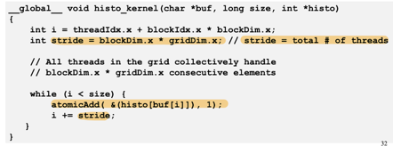
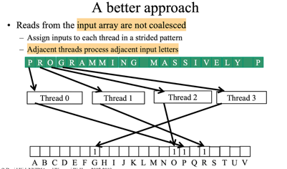
What about critical section for a grid? OK. As only one thread may modify sth.
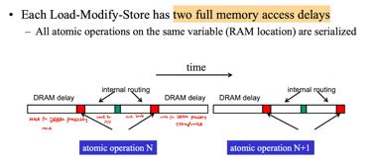
An atomic operation starts with a read, ends with a write, with a latency of a few hundred cycles.
Latency determines throughput of atomic operations. • Throughput of an atomic operation is the rate at which the application can execute an atomic operation on a particular location. • The rate is limited by the total latency of the read-modify-write sequence, typically more than 1000 cycles for global memory (DRAM) locations. • This means that if many threads attempt to do atomic operation on the same location (contention), the memory bandwidth is reduced to < 1/1000!
Hardware improvements: • L2 cache: medium latency but still serialized. Global to all blocks. “Free improvement.” • Atomic operations on Shared memory. Short latency, but still serialized. Private to each thread block.
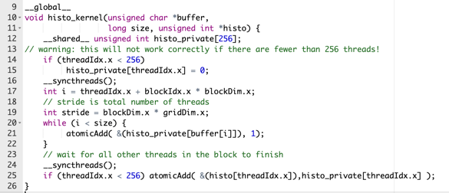
More: Histogram size needs to be small, fits into shared memory.
If too large, each block only corresponds to a specific region. Ignore out of the bounds. (handle by other block)
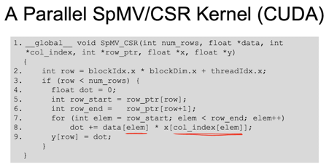
4. Sparce Matrix: CSR:
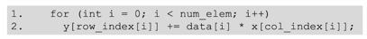
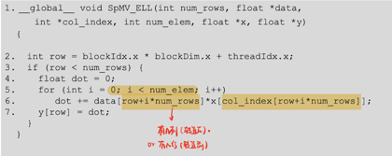
ELL: (to coalescing)
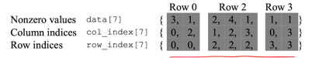
COO: (need atomic operations!) Allow reordering.
Hybrid Format (ELL+COO), ELL handle typical entries; COO handles exceptional entries (segemented reduction)
CSR runtime: block performance is determined by longest row.
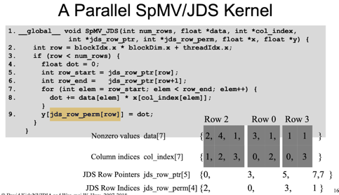
JDS(Jagged Diagonal Sparse): sort rows into descending order according to number of non-zero.
JDS with transposition -> overcome memory divergence.
5. GPU as part of PC Architecture (next page)
6. Data Transfer
cudaDeviceProp prop;
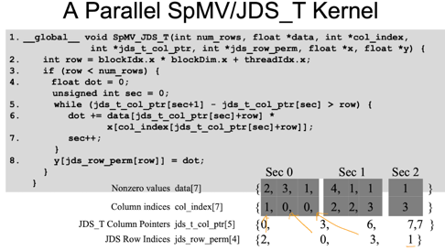
cudaGetDeviceCount (&dev_count);

cudaGetDeviceProperties (&prop,i);
prop.deviceOverlap.
Each stream is a queue of operations. Operations in different streams can execute in parallel. Device requests made from the host code are put into a queue.
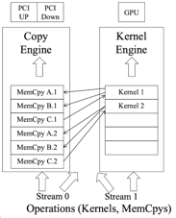
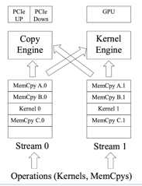
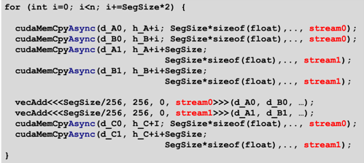
cudaStream_t stream0; cudaStreamCreate(&stream0);

Fermi: 16grids run at once, single queue, overlap only at stream edges; Kepler: one work queue per stream, concurrency at full-stream level; no inter-stream dependencies
Why has minimum: some SMs idle / too few warps to keep SMs busy / too few tgreads to fill a warp / load balance worse than fewer blocks / kernel launches take time
7. OpenACC: host <-> host memory <-> device memory <-> device
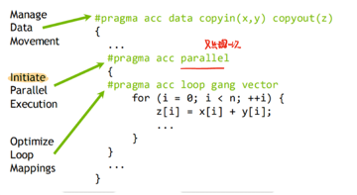
#pragma acc parallel loop copyin(M[0:Mh*Mw]) copyin(N[0:Nw*Mw]) copyout(P[0:Mh:Nw])
Attention: parallel only shows once
#pragma acc loop
OpenACC does not allow user-specified synchronization across threads.
Accelerator -> execution unit -> thread (include vector)
Gang -> workers -> vectors: copyout(a) num_gangs(1024) num_workers(32)
#pragma acc parallel loop reduction(+:sum)
FORTRAN: #pragma acc <directive> <clauses> -> !$acc <d> <c> !$acc end <d>
8. MPI: each node contain N GPUs; cudaSetDevice() sets the current GPU in a single node; current GPU can be changed while async calls/kernels/memcopy are running
MPIrun -np X (launch X processes); launch X nodes
int MPI_INIT(int *argc, char ***argv): initialize MPI
MPI_COMM_WORLD: MPI group formed with all allocated nodes
int MPI_Comm_rank(MPI_Comm comm, int *rank): rank of the calling process in comm group
int MPI_Comm_size(MPI_Comm comm, int *size): #processes in the group pf comm

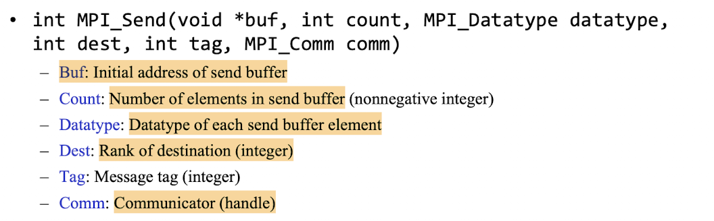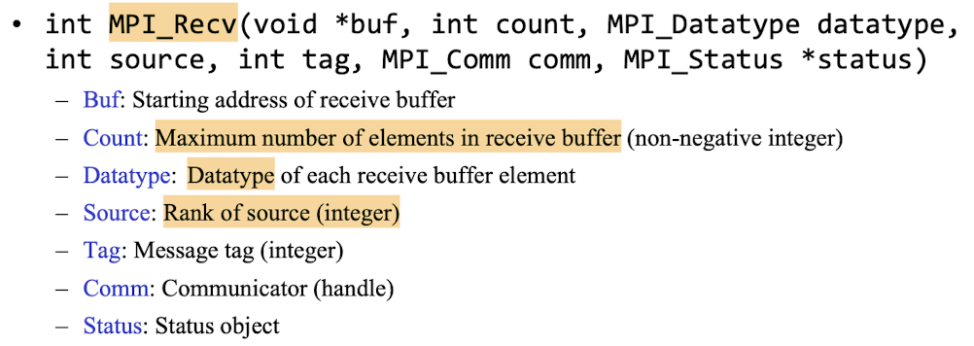
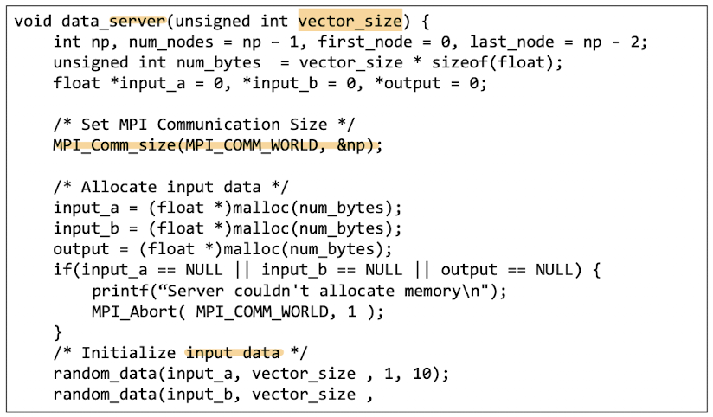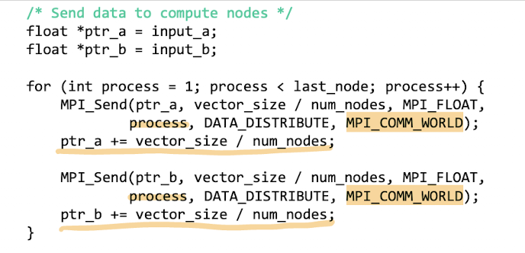
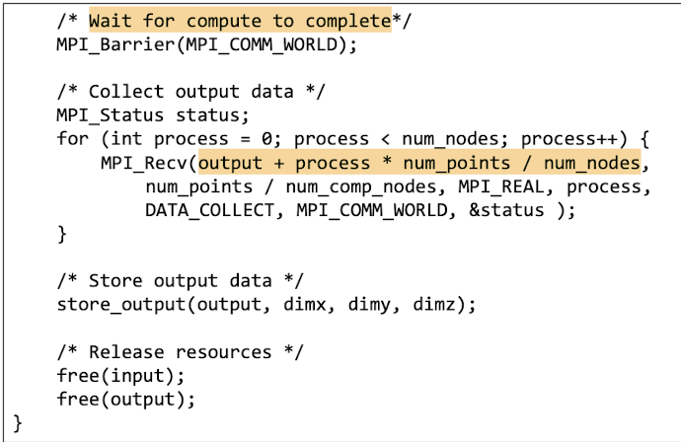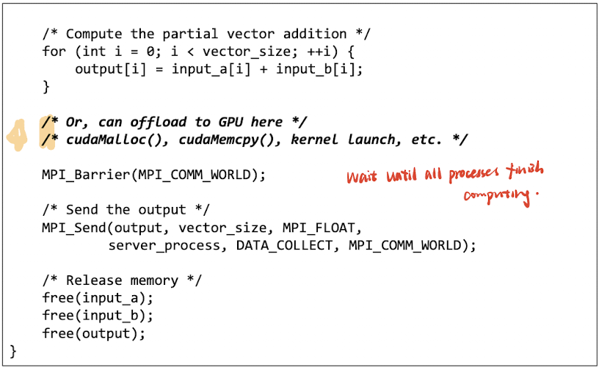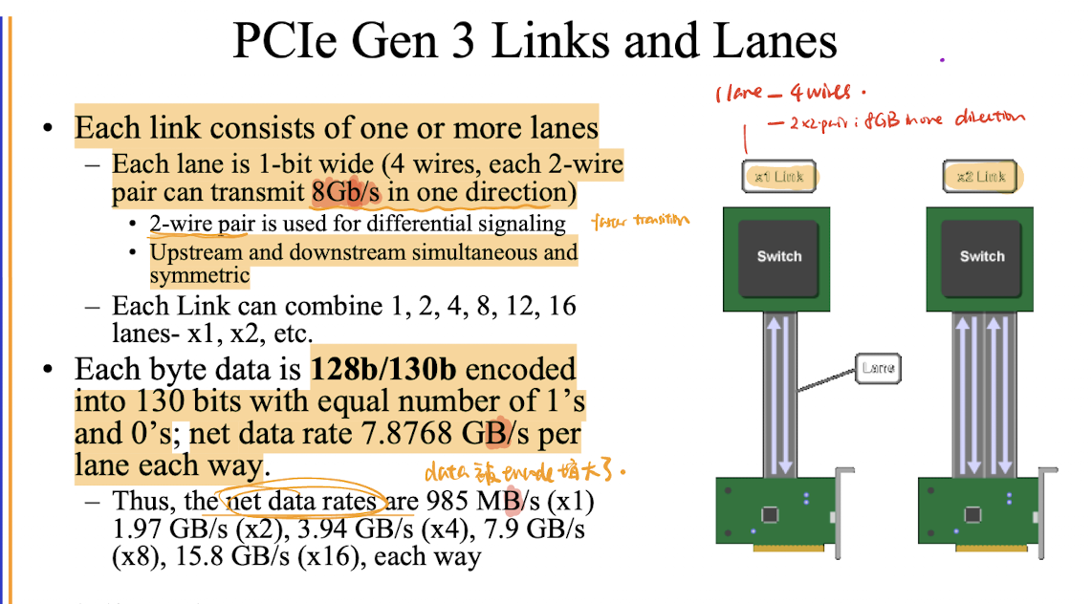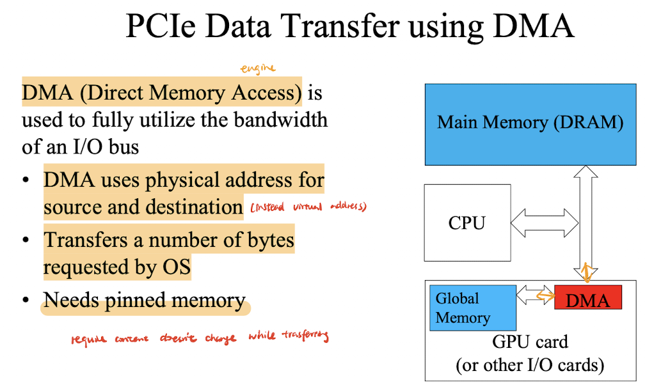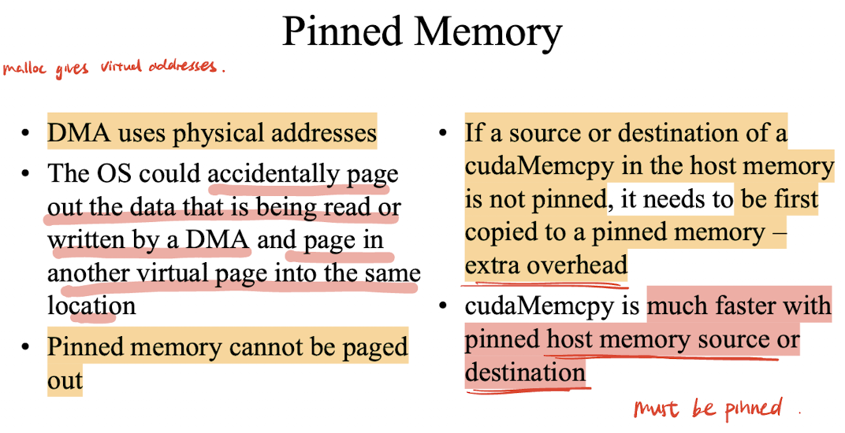
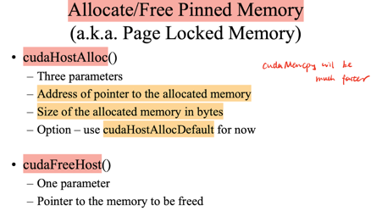
Using Pinned Memory
• The only difference is that the allocated memory cannot be paged by the OS
• The cudaMemcpy function should be about 2x faster with pinned memory
• Pinned memory is a limited resource whose over-subscription can have serious consequences

